**Section 1:**

**Question 1-10**

**Complete the form below.**

**Write NO MORE THAN ONE WORD OR A NUMBER.**

**Opening A Bank Account**

Application for a: Current bank account

Type of current account: The (1) _________________ account

Full name of applicant: Pieter Henes

Date of birth: (2) _______27th . 01.1973 __________

Joint account holders: No

Current address: (3) __________15 riverside_______ Exeter

Time at current address: (4) _______2 weeks__________

Previous address: Rielsdorf 2, Utrecht, Holland

Telephone: work (5) ______616295__________

Occupation: (6) ________ engineer _________

Identity (security): Name of his (7) ________mother_________ :Siti

Opening sum: (8) £ ______2000_________ to be transferred from Fransen Bank, Utrecht

Statements: Every (9) _______month__________

Requests: Supply information about the bank’s (10) _______internet__________ service

**Section 2:**

**Question 11-13**

**Choose the correct letter A, B and C.**

**The History of Rosewood House**

11. When the writer Sebastian George first saw Rosewood House, he

A thought he might rent it

B felt it was too expensive for him

**C was unsure whether to buy it**

12. Before buying the house. George had

A **experienced seevere family problems**

B struggled to become a successful author

C suffered a serious illness

13. According to the speaker, George viewed Rosewood House as

A a rich source of material for his books

**B a way to escape from his work**

C a typical building of the region

**Question 14-17**

**Label the map below.**

**Write correct letters A-J next to questions 14-17.**

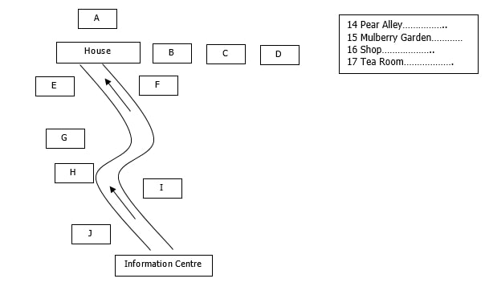

14 H

15 F

16 B

17 D

**Question 18-20**

**Complete the sentences below. Write ONE WORD ONLY.**

River Walk

18. You can walk through the _____field____________ that goes along the river bank.

19. You can go over the _________footbridge________ and then into a wooded area.

20. On your way back, you could also go up to the _____viewpoint____________

**Section 3:**

**Question 21-24**

**Complete the sentences below.**

**Write NO MORE THAN THREE WORDS OR A NUMBER.**

**Marketing Assignment**

21. For their assignment, the students must investigate one part of the _________________

22. The method the students must use to collect data is _________________

23. In total, the students must interview _______30__________ people.

24. Jack thinks the music preferences of ________male and female_________ listeners are similar.

**Question 25-30**

**Complete the notes below. Write NO MORE THAN TWO WORDS.**

**Marketing Survey: Music Preferences**

|  |  |
| --- | --- |
| **Age group of interviewee** | **\*** 25 or under **\*** 45 or over |
| **Music preferences** | **\*** Pop **\* 25 ______jazz_____** **\*** Folk **\*** Easy listening **\* 26 _____classical______** |
| **Medium for listening to music** | **\*** Radio **\*** CD **\*** TV **\* 27 ____concert_______** |
| **Source of music** | **\*** Music shops **\* 28 _______stores____** **\*** Internet |
| **Places for listening to music** | **\*** Disco **\***Pub **\* 29 ______club_____** **\*** Concert hall **\* 30 ___________** |

**Section 4:**

**Question 31-34**

**Choose the correct letter A, B or C.**

**Ireland In The Neolithic Period**

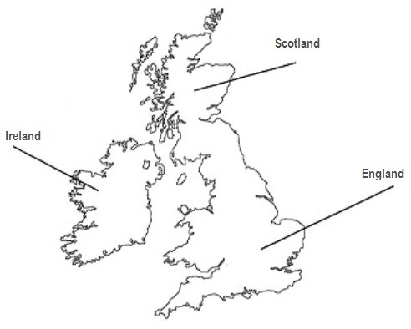

31. According to the speaker, it is not clear

A when the farming economy was introduced to Ireland

B why people began to farm in Ireland

**C where the early Irish farmers came from**

32. What point does the speaker make about breeding animals in Neolithic Ireland?

A Their numbers must have been above a certain level

B They were under threat from wild animals

C Some species died out during this period

33. What does the speaker say about the transportation of animals?

**A Livestock would have limited the distance the farmers could sail**

B Neolithic boats were loo primitive to have been used

C Probably only a few breeding animals were imported

34. What is the main evidence for cereal crops in Neolithic Ireland?

A the remains of burnt grain in pots

B the marks left on pots by grains

**C the patterns painted on the surface of pots**

**Question 35-40**

**Complete the sentences below. Write NO MORE THAN TWO WORDS each answer.**

**STONE TOOLS**

35. Ploughs could either have been pulled by _________people________ or by cattle. The farmers needed homes which were permanent dwellings.

36. In the final stages of axe-making __________water _______ and ________sand________ were necessary for grinding and polishing.

37. Irish axes were exported from Ireland to __________Scotland_______ and England.

**POTTERY MAKING**

The colonisers used clay to make pots.

38. The _________________ of the pots was often polished to make them watertight.

39. Clay from _________locals________ areas was generally used.

40. Decoration was only put around the _________________ of the earliest pots.